SOAR Playbook Report
Security Orchestration, Automation, and Response (SOAR) Playbook
Project Information

Objective
The objective of this activity was to design and test a SOAR playbook capable of automating the response process for phishing-related incidents. The playbook aims to reduce analyst workload, improve response times, and ensure consistent handling of malicious indicators.

Introduction
Security Operations Centers (SOCs) receive a large number of alerts daily. Manual investigation and response can be time-consuming and prone to errors. SOAR solutions automate repetitive tasks by integrating multiple security tools into a single workflow.
For this exercise, a phishing incident response playbook was created to automatically validate malicious IP addresses, block confirmed threats, create incident tickets, and notify security analysts.

Tools Used
- Splunk Phantom
- TheHive
- CrowdSec
- Wazuh SIEM
- VirusTotal

Playbook Workflow
The automated workflow follows the sequence below:
- Phishing alert received from Wazuh.
- Extract source IP address.
- Check IP reputation using VirusTotal.
- Determine threat score.
- If malicious:
  - Block IP through CrowdSec.
  - Create incident ticket in TheHive.
  - Notify SOC analyst.
- If not malicious:
  - Close alert as false positive.
- Document all actions automatically.

Workflow Diagram
Phishing Alert
↓
Extract IP Address
↓
VirusTotal Reputation Check
↓
Is IP Malicious?
↓
Yes
↓
Block IP via CrowdSec
↓
Create TheHive Case
↓
Notify Analyst
↓
Close Playbook

Playbook Execution Test
A simulated phishing alert was generated to verify playbook functionality.
Test Alert Information
Field | Value
Alert ID | PH-001
Source IP | 192.168.1.102
Alert Type | Phishing Attempt
Severity | High

Playbook Validation Results
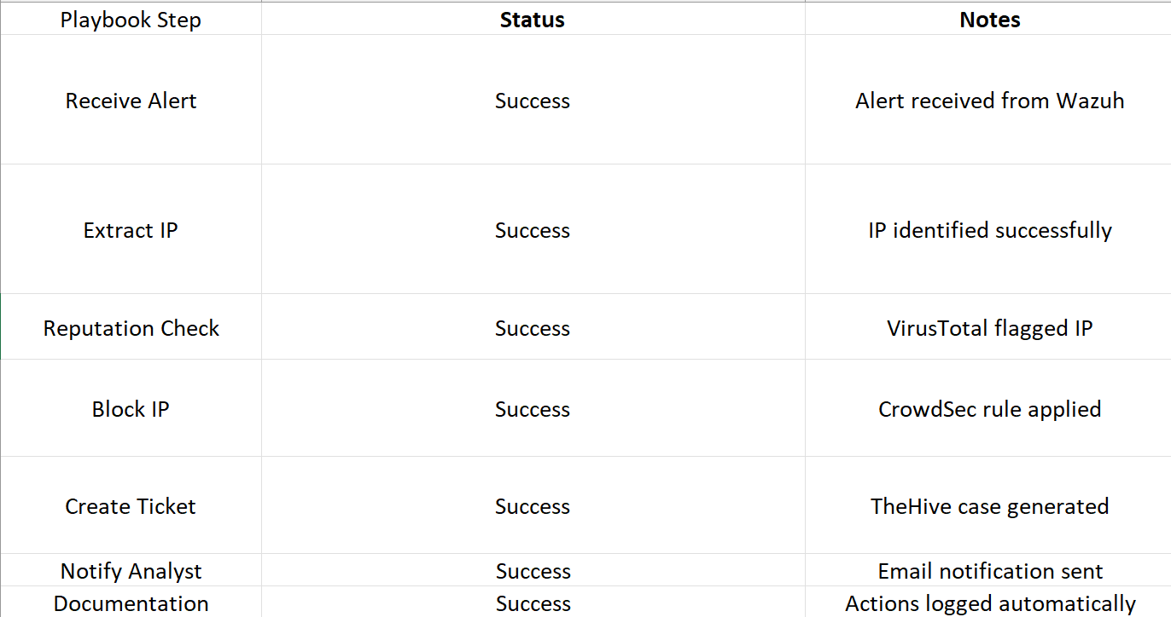
Incident Response Outcome
The playbook successfully identified a malicious IP address and automatically executed containment actions. The attacker IP was blocked before further communication could occur. An incident ticket was generated, allowing analysts to perform additional investigation while maintaining a complete audit trail.

Benefits of SOAR Automation
Faster Response
Automated actions reduce Mean Time to Respond (MTTR) by eliminating manual intervention for routine tasks.
Improved Accuracy
Automation ensures every incident follows the same predefined process, reducing human error.
Better Scalability
The SOC can handle a larger number of alerts without increasing analyst workload.
Enhanced Visibility
All actions are automatically documented and tracked for compliance and auditing purposes.

Challenges Identified
- Dependence on accurate threat intelligence feeds.
- Potential false positives from automated decisions.
- Requirement for regular playbook updates.
- Integration complexity across security platforms.

Recommendations
- Regularly update threat intelligence feeds.
- Review blocked indicators periodically.
- Test playbooks monthly.
- Expand automation to malware and ransomware incidents.
- Implement approval workflows for critical actions.

Conclusion
The SOAR playbook successfully automated the phishing incident response process. The workflow reduced manual effort, accelerated containment actions, and ensured consistent incident handling. Automated blocking, ticket creation, and analyst notification demonstrated the effectiveness of SOAR technology in modern Security Operations Centers. Future improvements should focus on expanding automation coverage and integrating additional threat intelligence sources to further enhance security operations.

